GITHUB Procedure

This is assuming you’ve installed GitHub for windows; and using GIT Shell

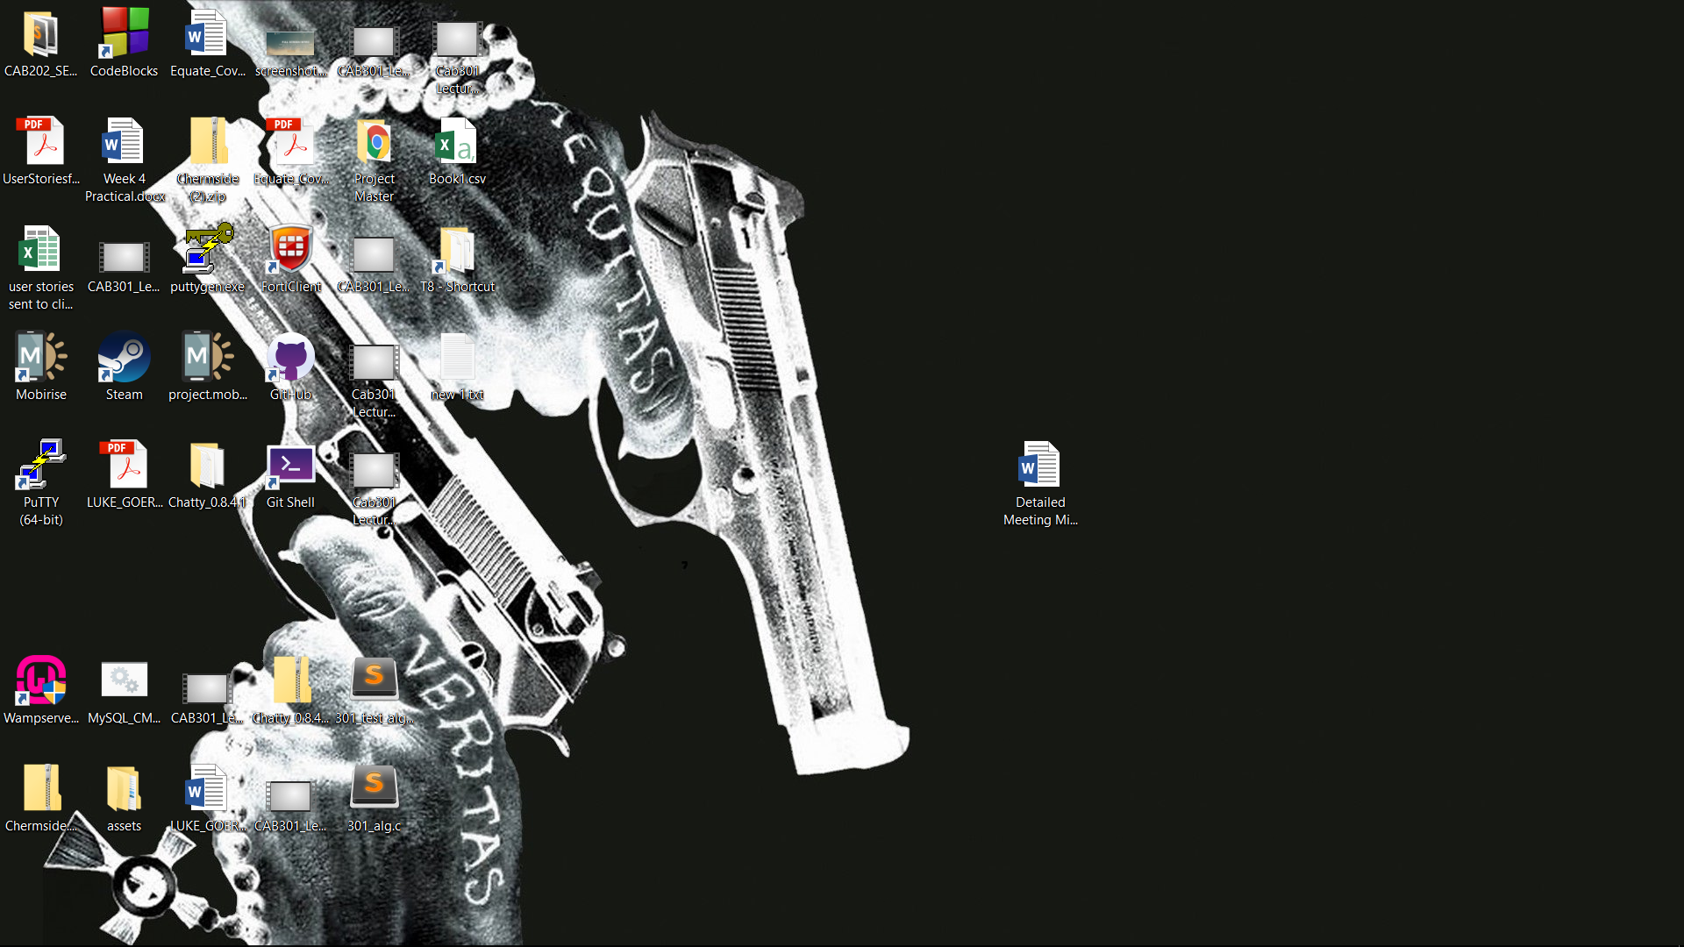

Setup and Cloning

1. Decide on location to sync work folder too (**C:\299**)
2. Open Git Shell and change directory to the folder above (**cd C:/299**)
3. Once in directory; perform sync using sync address found on git hub
   1. “**git clone** [**https://github.com/lukegoeree/IFB299_2017SEM1_Group36.git**](https://github.com/lukegoeree/IFB299_2017SEM1_Group36.git)”
4. A new working directory will be created (C:\299\IFB299_2017SEM1_Group36)
   1. This will be your new working folder; modify and create file in this folder
5. Change to new working folder in Git Shell
   1. “**cd IFB299_2017SEM1_Group36**”
6. You will need to make sure you’re in this folder every time you work on the project

Update and Uploading

1. Save any work/modifications you’ve done in the IFB299_2017SEM1_Group36 folder
2. In Git Shell type “**git status**”. This will tell you if Shell has picked up any new changes
3. “**git add –A**”: Will add all modified/new files to upload package
4. “**git commit –m “type message here”**”: The message is important and won’t upload with it. Just describe what changes you made.
5. “**git push**”: Will push your upload package up to GitHub
6. “**git pull**”: Will pull down the most current version of our GitHub repository

Just remember to pull down the latest version every time you start work again. It’ll make sure your working folder includes everyone’s updates.